|  |  |
| --- | --- |
| **Subject** | Object Oriented Programming |
| **Assignment 1** | Messaging App Simulator |
| **Assignment No. 1 (BSE-B)** | |
| **Submitted By:**  SP24-BSE-005 Abeera Rehman | |  |

**Submitted To:**

|  |  |
| --- | --- |
| **Moderator** | Prof. **Shahid Bhatti** |

The code consists of three classes, i.e. Main class, Message class and MessageApp class.

**Main class:**

* Menu selection acting as the entry point for each method in MessageApp class.

**Message Class:**

* Attributes:
  + **Final String sender:** The name of the sender (fixed as "Abeera").
  + **String receiver:** The name of the message receiver.
  + **String content:** The content of the message.
  + **LocalDateTime** **timestamp:** The timestamp of when the message was created.
  + **MessageStatus status:** (Enumeration: SENT or READ)
  + **String messageID:** A unique identifier for each message.
  + private static int counter: A static counter to generate message IDs.
* Methods:
  + public Message (String receiver, String content, LocalDateTime timestamp): **Constructor** to initialize a new message.
  + Getters and setters for attributes.
  + @Override public String toString(): Returns a string representation of the message details.
  + @Override public boolean equals(Object o)

**MessageApp Class:**

* **Attributes:**
  + **Message[] messages**: An array to store messages.
  + **String[][] contacts**: A 2D array to store contacts (name and phone number).
  + **int messageCount**: Counter for the number of messages.
  + **private int contactCount**: Counter for the number of contacts.
* **Methods:**
  + **MessageApp()**: Constructor to initialize the messaging application.
  + **void addContact()**: Adds a new contact.
  + **void sendMessage()**: Sends message to a specified receiver.
  + **void readMessages()**: Reads messages sent to a specified receiver and updates status.
  + **boolean isMessageDelivered()**: if a message was delivered to a specified receiver.
  + **void sortMessages()**: Sorts messages by their timestamp.
  + **void searchMessages()**: Searches for messages sent to a specified receiver.
  + **void displaySpecificMessage()**: Displays a specific message based on the receiver's name and message ID.
  + **void deleteMessage()**: Deletes a specified message from the message list.
  + **void ()**: Displays the list of contacts

**Code Snippets:**

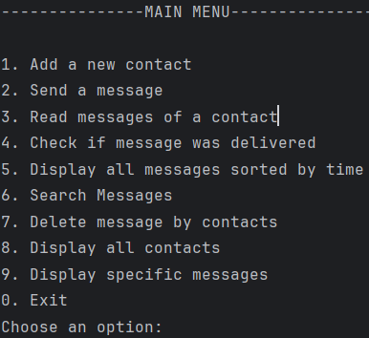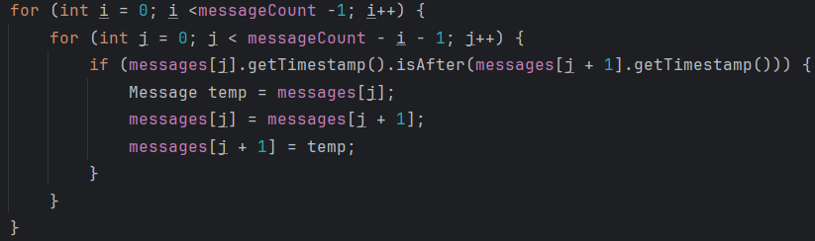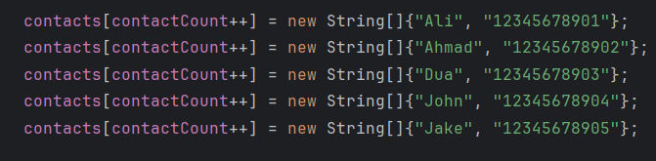

**Outputs:**

* Bubble sort to sort messages based on their timestamps
* To add predefined contacts in contacts array

Pressing **1**:

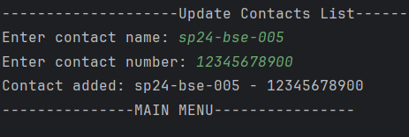

Pressing **2**:

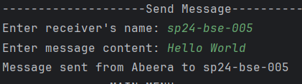

Pressing **3**:

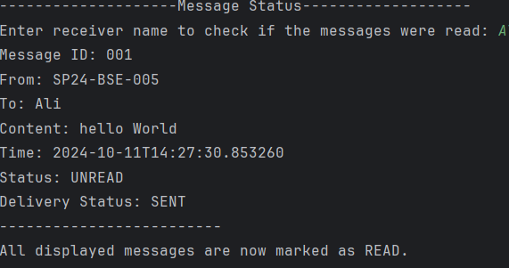

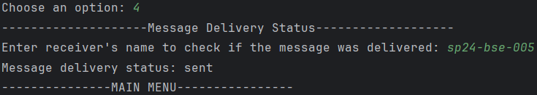Pressing **4**:

Pressing **5**:

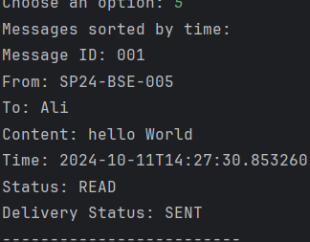

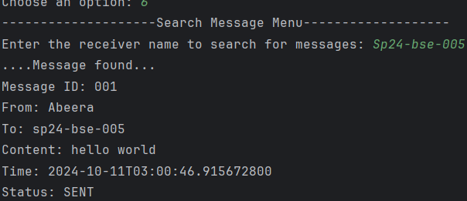Pressing **6**:

Pressing **7**:

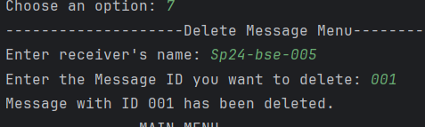

Pressing **8**:

Pressing **9**:

